**CH5120: Project 1A Report**

**S Tarun Prasad – ME17B114**

**Code Explanation:-**

**Without Constraints:**

* For generating the step response matrix for the given MIMO system, the individual step response matrices are computed and the elements of it are ordered in the appropriate way for the overall step response matrix using a loop.
* The weights, setpoints, prediction and control parameters are set after this.
* The Su matrix is computed using a loop using the elements of the Su matrix and the gamma-U matrix is also computed using the same loop using the appropriate weights for the appropriate inputs.
* The gamma-Y matrix is computed using a different loop and the left-hand constraint matrix and Hessian is also computed in this section.
* The predicted error is now being computed from the third element onwards due to the two output MIMO system.
* The gradient is being computed in each iteration of the loop and the change in input is computed by multiplying the inverse of Hessian with a negative of the gradient.
* A 2-Step Forward Shift is used for the state update.
* A 2*2 Plot showing the behaviour of each input and output is generated.

**With Constraints:**

* There are two changes from the code for unconstrained MPC.
* The Right-Hand constraint is now being computed in each iteration of the implementation loop.
* The change in output in each step is now being computed using quadprog function to which the Hessian, Gradient and Constraints are fed.

**Variation with Weights:**

* **Input Weights: .1,.1 Output Weights=1,1**

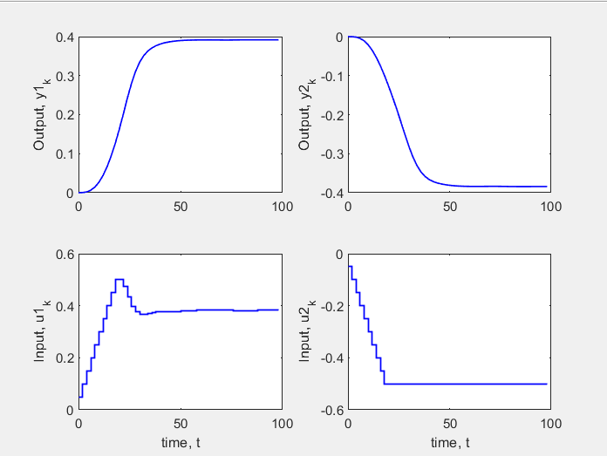

* **Input Weights: 1,1 Output Weights=1,1**

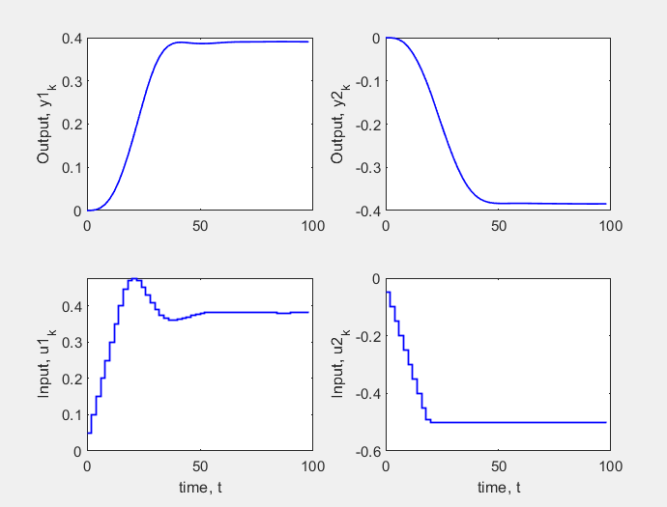

* **Input Weights: 1,1 Output Weights=10,1**

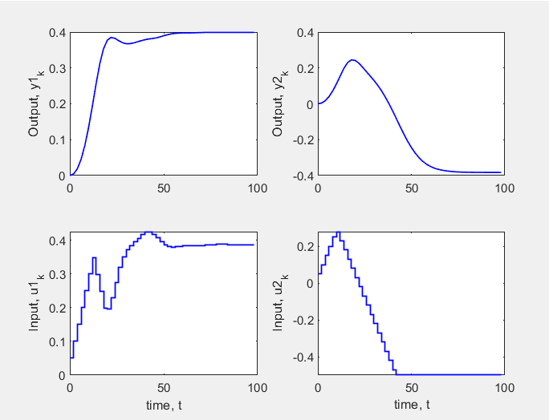

* **Input Weights: 1,1 Output Weights=1,10**

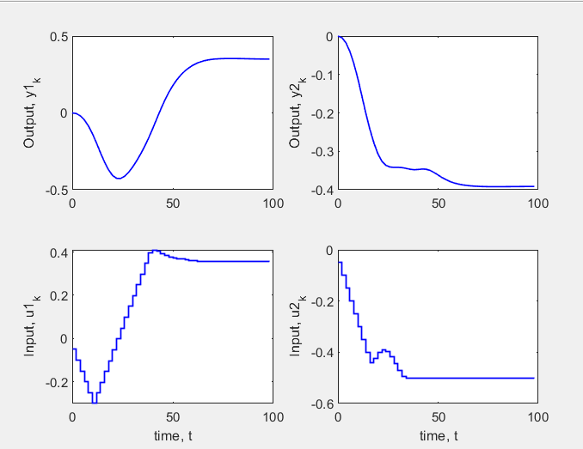

* **Input Weights: 10,10 Output Weights=1,1**

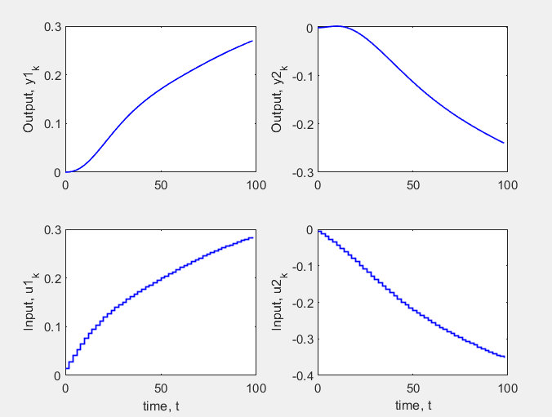

* **Input Weights: 0.05,0.05 Output Weights=6,6**

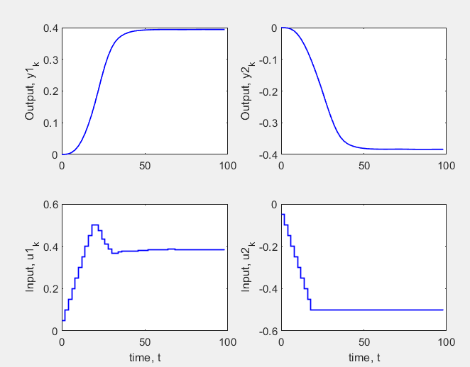

**Inferences:**

* Equal weights magnitude 1 and .1 respectively for both outputs and both inputs of magnitude 1 and .1 generate reasonable plots with both the outputs settling to the setpoints with a minimal offset.
* The offset increases when the input weights both become 1.
* When one of the output weights has a higher bias that particular output settles perfectly while the other output has a big oscillation in the opposite direction of its setpoint initially and later settles with an offset.
* When the input weights are of an order higher than the output weights the outputs do not settle to the setpoints.
* For equal output weights of 6 and input weights of .05, the first output perfectly settles and the second output has a small offset.